CS306 Project Step 2

Zeynep Yıldız (00029325) | CS 306

First of all I choose my Patient table which has pid (primary key), pname and page attributes:

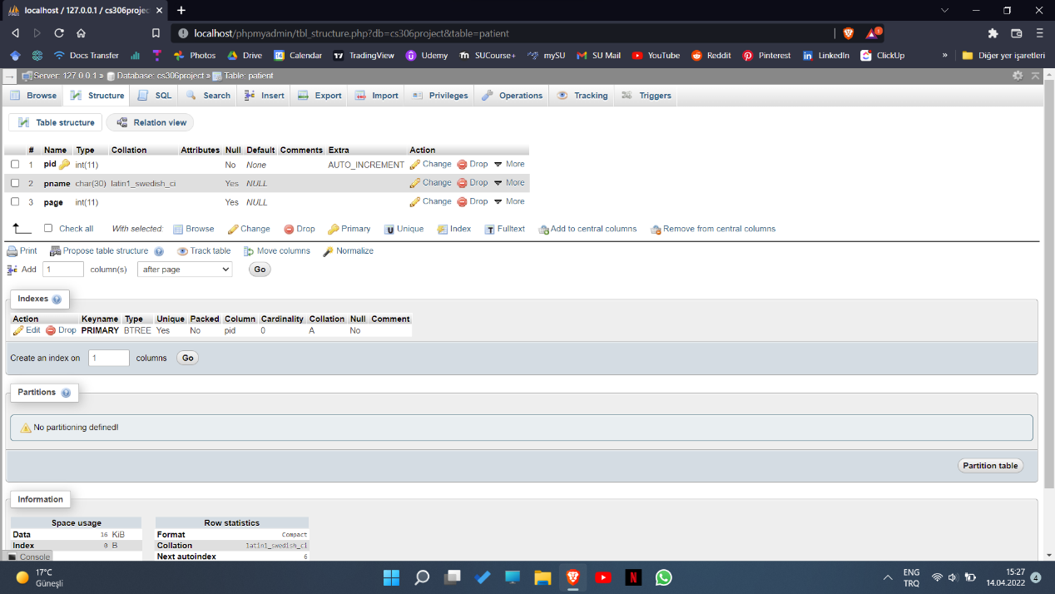

//********************* Web interface****************************//

### First Look

The first look at the web interface is this (without adding any patients)

index page:

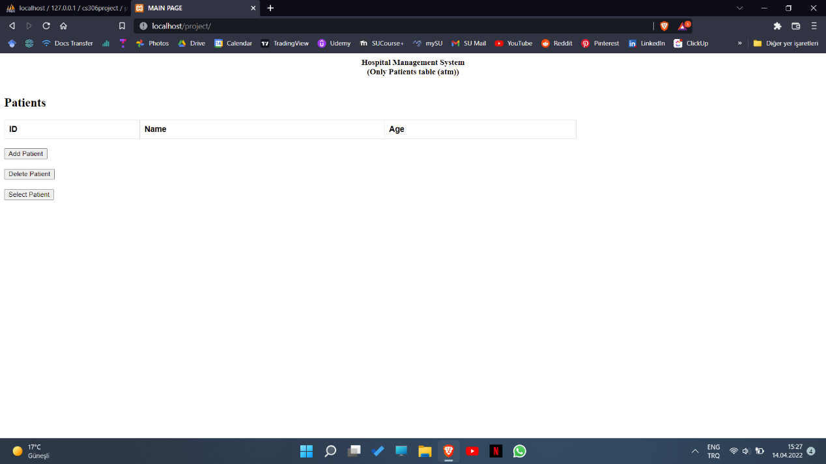

Add patient page:

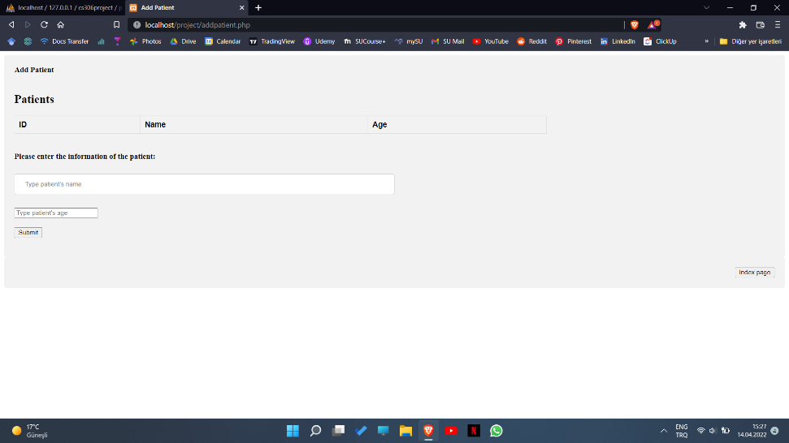

Delete patient page:

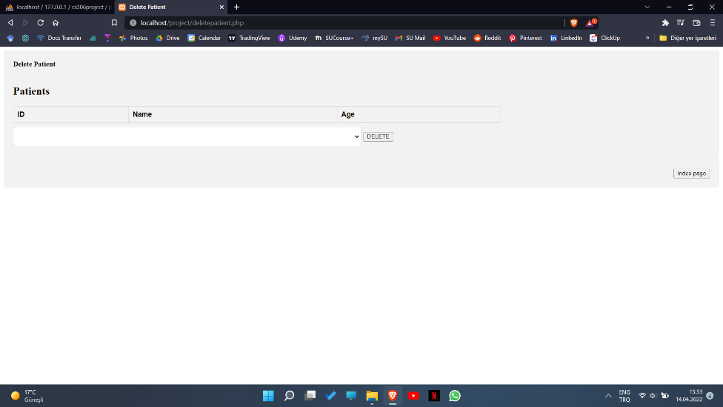

Select Patient page:

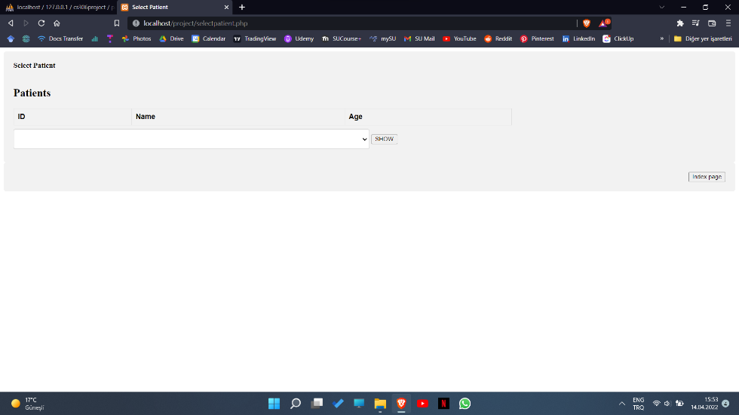

### Add Patient

When we add patients from the add patient page it automatically goes back to index page with the list:

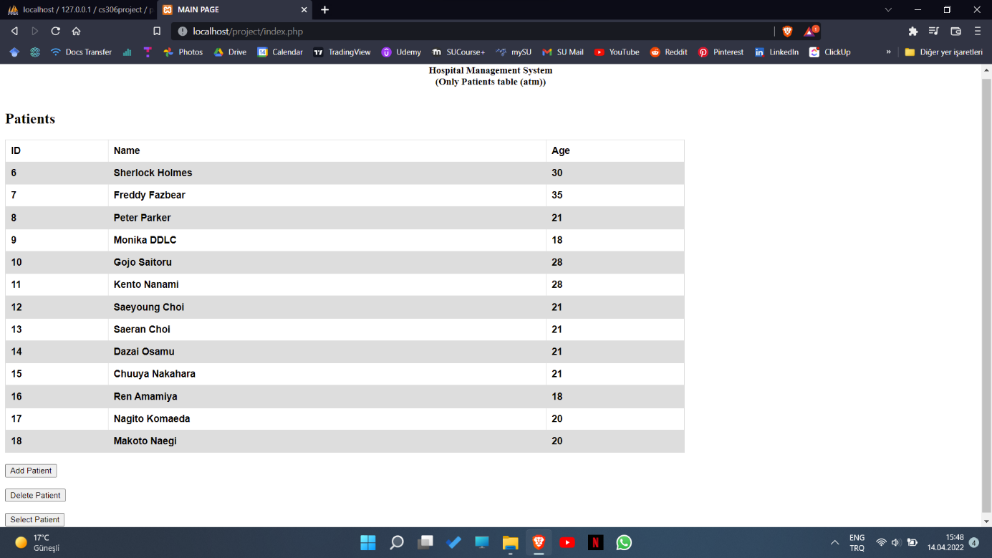

### Select Patient

Selecting patients allows to choose an existing age and shows all patients with that age:

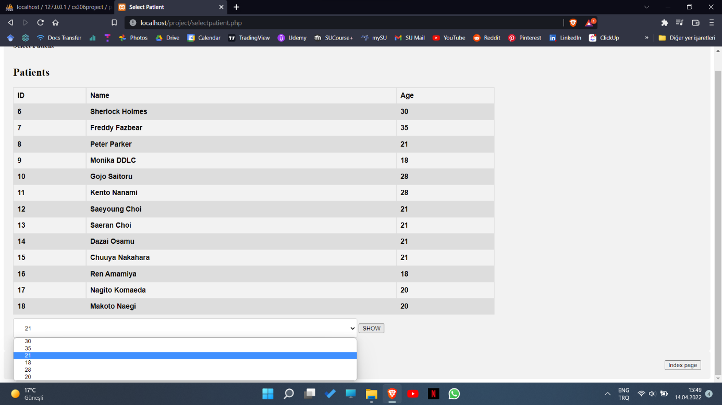

For example choosing 21 and clicking on “show” will take us to:

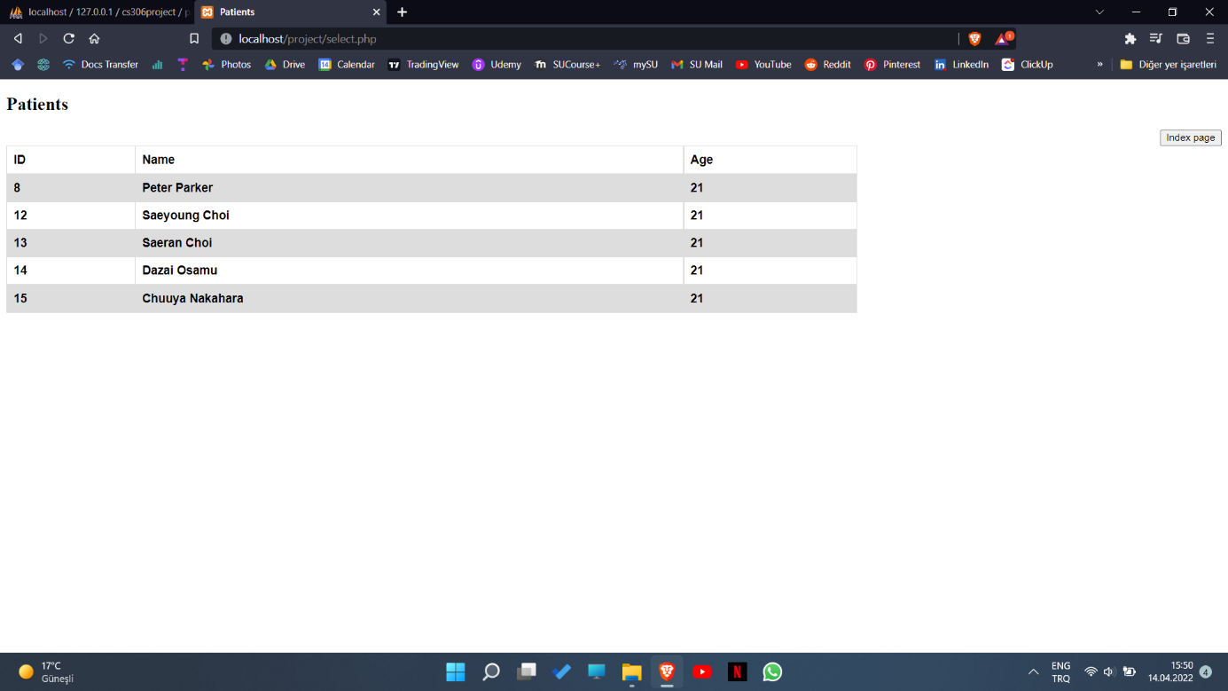

Another example:

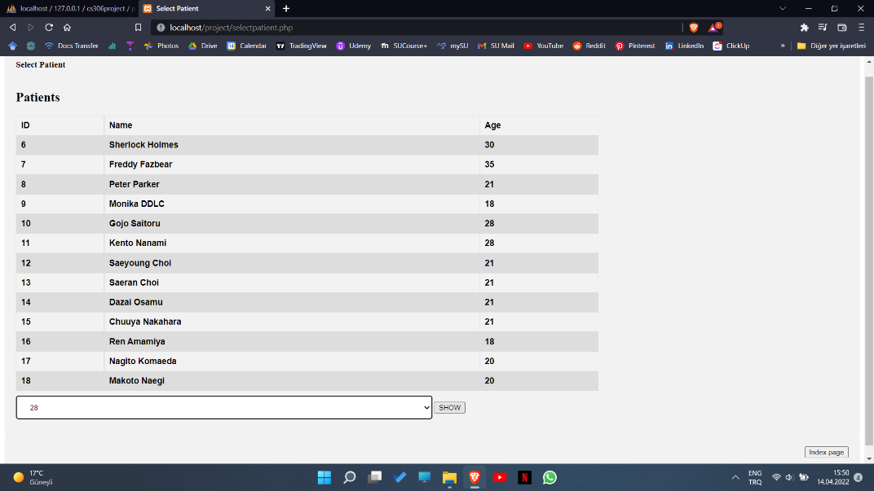metin içeren bir resim

Açıklama otomatik olarak oluşturuldu

### Delete Patient

Delete Patient page allows to delete patients by choosing their id:

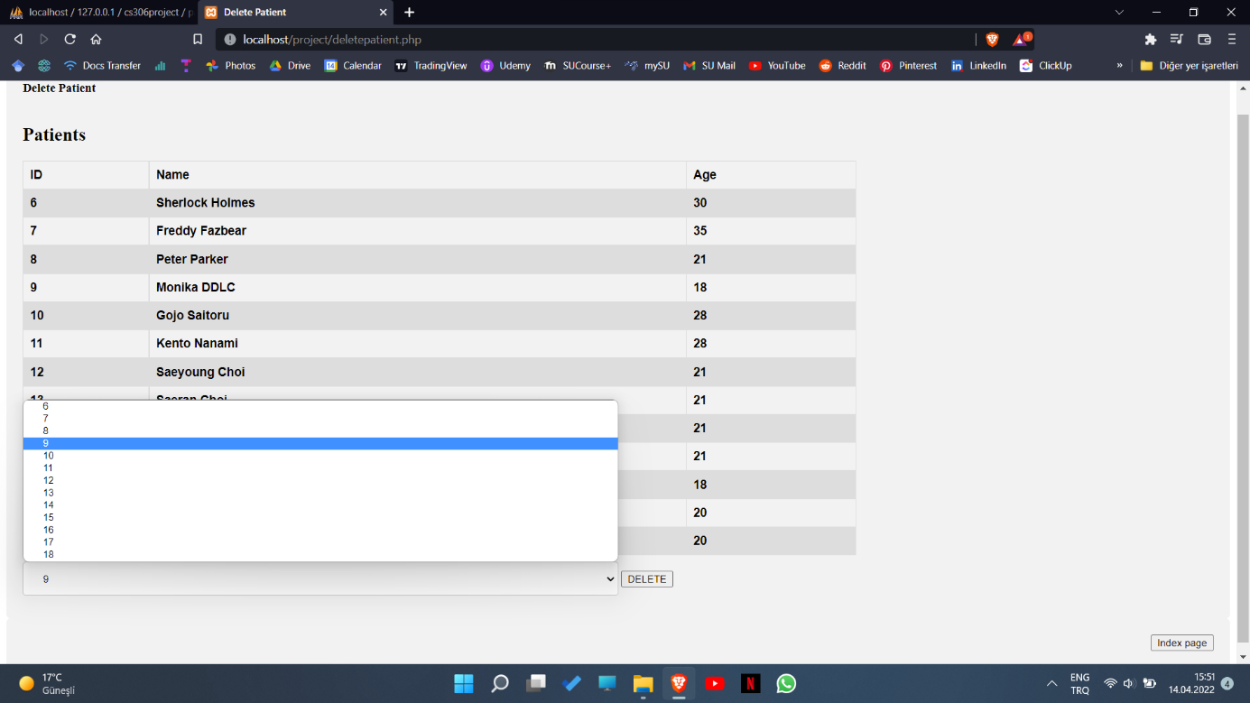metin, ekran görüntüsü, bilgisayar, ekran içeren bir resim

Açıklama otomatik olarak oluşturuldu

Another example:

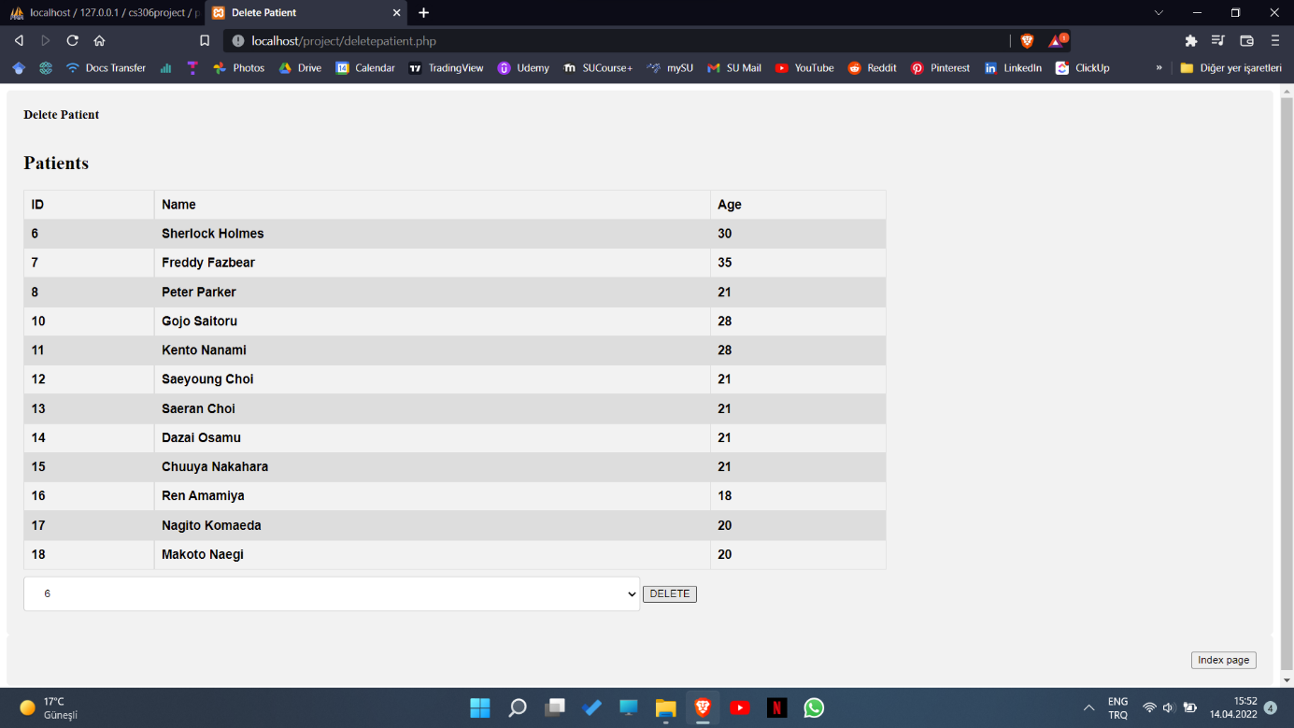metin, ekran görüntüsü, ekran, bilgisayar içeren bir resim

Açıklama otomatik olarak oluşturuldu